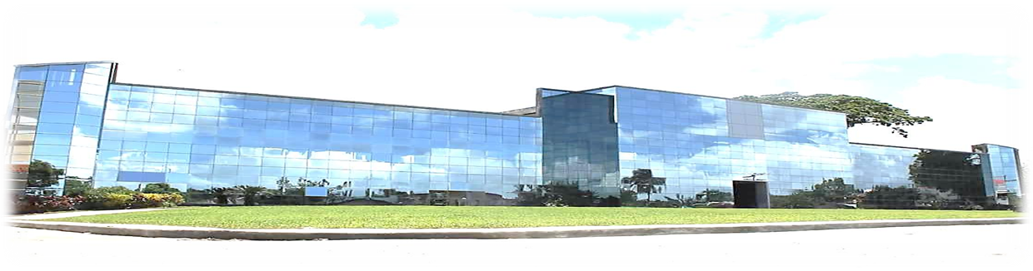
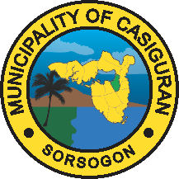
Republic of the Philippines
Province of Sorsogon
MUNICIPALITY OF CASIGURAN

________________

POST-QUALIFICATION EVALUATION REPORT

{{project_title_upper}}

Name of Bidder: {{company_name_upper}}
Rank on the list of bids: 1st
Bid Price: PHP {{bid_amount}}
Results of Post-Qualification: Found Responsive
Requirements |  | Parties Consulted | Findings
ELIGIBILITY ENVELOPE
 | DTI Business Name Registration | Presented Original Copy | Passed
 | Mayor’s Permit | Presented Original Copy | Passed
 | Omnibus Sworn Statement | Presented Original Copy | Passed
 | Audited Financial Statements | Presented Original Copy | Passed
 | Tax Clearance | Presented Original Copy | Passed
 | NFCC or Credit Line or Cash Deposit Cert. | Submitted Original Documents | Passed
 | Bid Security (Bid Securing Declaration) | Submitted Original Documents | Passed
 | Cert. of PhilGEPS Registration | Presented Original Documents | Passed
 | Delivery Schedule | Submitted Original Documents | Passed
 | Schedule of Requirements | Submitted Original Documents | Passed
FINANCIAL ENVELOPE
 | Bid Prices in Bill of Quantities | Submitted Original Documents | Passed
 | Bid Proposal Form | Submitted Original Documents | Passed
 | Detailed Estimates | Submitted Original Documents | Passed
 | Cash Flow by Quarter and Payment Sched. | Submitted Original Documents | Passed
OTHER DOCUMENTS REQUIRED
3 sets of Bidding Documents |  | Submitted Original, Copy1&2 Documents | Passed

Noted:
ARLIE H. CORAÑES
BAC Chairman

